­­­

|  |
| --- |
| ARDEN UNIVERSITY |
| BSC (HONS) COMPUTING |
| SYSTEM ANALYSIS AND DESIGN |
| SYSTEM ANALYSIS AND DESIGN |
| STU146134 |
| ZINSHO VASHUM |
| 2876 |

Contents

TASK 1 2

TASK 2 5

PART 1 5

PART 2 7

PART 3 9

TASK 3 11

TASK 4 21

Reference 23

# TASK 1

CURRENT MARKET: In the UK and Germany, Harmony Care Ltd Hospital is a private healthcare facility that offers a variety of medical services, such as consultations, tests, procedures, and postoperative care

SERVICES: The hospital employs about 1000 people and has five branches in the UK and one in Germany. However, they currently have difficulties with overbooking appointments, resource allocation, and effectively handling patient records, appointments, and payment across several sites.

PROBLEMS:

* Inconsistent of patient record: Inconsistencies can also be caused by mistakes or inaccuracies in patient data, such as misspellings, information that is missing, or records that are out of date. Inconsistencies are more likely to arise if appropriate safeguards are not in place to guarantee the quality of the data.
* Duplication of data: When a patient receives care at several hospital departments or locations, duplicate patient records could be produced. For a given patient, many departments might create separate records, which could result in redundant and inconsistent data.
* Manual patient registration: Variations and inaccuracies can happen when patient data is manually entered by various staff members into separate systems or databases. Inconsistencies could arise, for instance, if one department records information in a different format or using abbreviations than another department.
* Limited resources: The infrastructure, machinery, and facilities that are required to provide healthcare services are referred to as physical resources. Inadequate facilities for patient care, crammed waiting rooms, and a lack of necessary medical supplies or equipment can all be consequences of scarce physical resources.
* System limitations: For the purpose of sending appointment reminders, healthcare companies might just use a few different channels of contact, including emails or phone calls. Patients might not get notices on time if they would rather get reminders via other means (such as text messages or smartphone apps).
* Billing issues: Technical problems with healthcare providers' billing systems and software, such as malfunctions in the system or problems with data integration, might increase the possibility of invoicing errors. These problems may interfere with billing procedures, result in inaccurate billing statements, and affect the timeliness and accuracy of financial reporting.
* Inventory tracking issues: Problems with inventory tracking can result in overstocking, where extra inventory takes up expensive storage space and financial resources, or stockouts, when necessary supplies or prescriptions are unavailable when needed. Both situations have the potential to impair patient care, raise expenses, and lead to ineffective inventory control.

BENEFITS OF NEW SYSTEM

* CENTRALISED PATIENT REGISTRATION SYSTEM

Error risk will be decreased by centralized patient registration, which will remove duplicate records and guarantee consistency of patient data. Simplifies administrative procedures and boosts patient information management effectiveness.

* APPOINTMENTS SCHEDULING AND TIMELY NOTIFICATIONS

Workflows will be streamlined, waiting times will be decreased, and resource usage will be optimized through the automation of operations like resource allocation and appointment scheduling. Appointment reminders and notifications sent out on time will enhance the entire experience and happiness of patients.

* RESOURCES ALLOCATION OPTIMISATION

Intelligent resource allocation algorithms that optimize the distribution of physicians, rooms, and medical equipment by taking into account variables including patient demand, staff availability, and equipment consumption. increases the effectiveness of resource use by making sure that the appropriate resources are accessible when and where they are needed to fulfill patient needs.

* AUTOMATED BILLING AND INVOICING

Accurate bills are produced by an automated billing and invoicing system based on patient co-payments, insurance coverage, and services provided.

Automated invoicing and billing will reduce mistakes and inconsistencies, guaranteeing prompt bill processing and enhancing cash flow management.

* INVENTORY MANAGEMENT

Medical equipment, drugs, and supplies may all be tracked in real time with this inventory management system that scans barcodes. In order to avoid stockouts and delays in patient treatment, a strong inventory management system will allow precise tracking of goods and prompt replenishment.

I decided to employ the Agile Development Methodology for this software development after carefully analysing the report for the following reasons:

1. Adaptability to Changing Requirements: Agile methodologies, such as Scrum, are highly adaptive to changing requirements. In the healthcare sector, regulations, patient needs, and technological advancements can change rapidly. Agile allows teams to respond quickly to these changes and adjust project priorities accordingly.
2. Provides estimated time: The goal of agile approaches is to produce functional software more quickly. In doing so, Harmony Care will be able to improve patient care and operational efficiency more swiftly by meeting pressing requirements and bringing new features or improvements to market sooner.
3. Ensures customer satisfaction: Agile approaches place a high value on teamwork and client satisfaction. Agile guarantees that stakeholders, like as patients and healthcare providers, are effectively involved in the development process and that the end product effectively meets their requirements and expectations.
4. Less Risk: Project risks are reduced by using agile approaches, which place a strong emphasis on incremental delivery and frequent feedback. By taking timely, consistent action to resolve possible problems

# TASK 2

# PART 1

ACTORS

1. Doctors
2. Patients
3. Healthcare providers

USER CASERS

1. PATIENT REGISTRATION

ACTOR: Patient  
Normal scenario:  
Precondition: The patient shows up for a medical appointment at HarmonyCare Ltd.

1.1 The patient is greeted and the registration procedure is started by the registration team.   
1.2 The staff asks for the patient's name, address, phone number, and medical history, among other sensitive data.   
1.3 The patient gives the details that are needed.   
1.4 To avoid duplicate records, the system checks to see if the patient is already listed in the database.   
1.5 In the event that the patient is new, the system generates a new record containing their details and allots a special patient ID.   
1.6 The patient receives their patient ID and confirmation that their registration was successful.   
Postcondition: The centralized patient database contains the patient's data.

1. APPOINTMENT SCHEDULING

ACTOR: patient, healthcare providers

Normal scenario:

precondition: A consultation with the patient is necessary.

2.1The patient makes an appointment by calling HarmonyCare Ltd., visiting their website, or coming in person.

2.2 For the desired date and time, the system verifies that medical professionals, exam rooms, and necessary equipment are available.

2.3 The system sets up the appointment and issues a distinct appointment ID, if available.

2.4 The appointment is confirmed to the patient, along with the day, time, and place.

2.5 The patient shows up for the appointment at the hospital on the designated date.

2.6 The medical professional follows the appointment schedule when performing the consultation or operation.

Postcondition: The patient obtains the required medical care, and the appointment information are entered into the system.

1. BILLING AND INVOICING

ACTOR: healthcare providers, patient

Normal Scenario:

Precondition: The patient obtains healthcare services.

3.1 The healthcare provider starts the billing procedure after finishing the service.

3.2 Based on the services provided, the system creates an invoice that includes consultation fees, procedure expenses, and any other applicable fees.

3.3 The system sends invoice to patient. After, looking over the invoice, the patient pays using a variety of options.

3.4 The system marks the invoice as paid and changes the patient's financial information after the payment is processed.

Postcondition: The patient's financial status is updated in the system and the payment is noted.

1. INVENTORY MANAGEMENT

ACTOR: ADMINISTRATOR

Normal Scenario:

Prerequisite: The hospital must keep track of its medical supply inventory.   
  
4.1 The hospital's inventory management system is used by the inventory administrator to keep an eye on the inventory levels.   
4.2 When an item's stock drops below a predetermined threshold, the system sends out alerts.   
4.3 The administrator checks the inventory status after getting alerts.   
4.4 The administrator uses the system to place orders for replenishment if needed.   
4.5 After supplies are received, the system updates the inventory records.   
Postcondition: The hospital has a sufficient supply of medical goods in stock and maintains inventory levels.

# PART 2

1. PATIENT REGISTRATION

|  |  |  |  |  |  |
| --- | --- | --- | --- | --- | --- |
| User case | Events | Source | Action | Object | Destination |
| Patient Registration | Receptionist starts the registration process | Receptionist | Starts the process | Patient registration process | System prompts for information |
| Patient Registration | Receptionist enters details of the patient | Receptionist | Enters | Patient details | System validates information |
| Patient Registration | System validates information | System | validates | information | If validation successful: creates new patient record  If validation failure:  Then correction required |
| Patient Registration | System creates patient record | System | creates | New patient record | Patient record is stored in database |
| Patient Registration | System displays confirmation message | System | displays | Confirmation  message | Displays in the screen |

1. APPOINTMENT SCHEDULING

|  |  |  |  |  |  |
| --- | --- | --- | --- | --- | --- |
| User case | Events | Source | Action | Object | Destination |
| Schedule  appointment | Receptionist  Schedule new appointment | Receptionist | Schedule | Appointment | System verifies availability and schedules appointment |
| Schedule  appointment | System sends appointment  Confirmation to patient | System | sends | Appointment confirmation | Sent to the patient through email |
| Confirm Appointment | Patient confirms appointment | Patient | confirms | Appointment | Appointment status updates on the system |
| Sends Appointment remainders | Notification sent to patient | System | Sends | Reminder  notification | Patient receive the reminder about the appointment |
| Attend appointment | Patient attends appointment | patient | Attends | Appointment | Patient check-in by receptionist |

1. BILLING AND INVOICING

|  |  |  |  |  |  |
| --- | --- | --- | --- | --- | --- |
| User case | Events | Source | Action | Object | Destination |
| Generates invoice | Healthcare provider completes patient consultation | Healthcare provider | completes | consultation | System generates consultation bill |
| Process payment | Billing department reviews and approves consultation bill | Billing department | Reviews and approves | bill | System generates final bill |
| Process payment | System sends invoice to patient | System | Sends | invoice | Sent to the patient through SMS or email |
| Process payment | Patient makes payment | Patient | makes | payment | Payment recorded in the system |

1. INVENTORY MANAGEMENT

|  |  |  |  |  |  |
| --- | --- | --- | --- | --- | --- |
| User Case | Events | Source | Action | Object | Destination |
| Allocates Resources | Administrator reviews resource utilization data | Administrator | Reviews | Resource utilization data | System provides resource allocation recommendation |
| Allocate Resource | Administrator  Allocates doctors, rooms, and equipment | Administrator | Allocates | Doctors, rooms and equipment | System updates status |
| Allocate Resources | Healthcare provider accesses allocated resources | Healthcare | Accesses | Allocated resources | Resources available |
| Generate Resource utilisation report | System generates resource utilisation report | System | Generates | Resource utilisation report | Report available for review by administrator |

# PART 3

1. PERFORMANCE

Requirement: The system must be quick to respond, effective, and able to manage numerous users and requests simultaneously.

Optimisation Recommendations:

1.1 Use caching techniques to speed up response times and minimize database requests.

1.2 To maximize processing speed, employ effective algorithms and data structures.

1.3 To uniformly distribute user requests among server nodes, employ load balancing techniques.

1.4 To find and fix bottlenecks, periodically assess system performance using performance testing.

1. RELIABILITY

Requirement: To guarantee continuous service, the system must be dependable, have little downtime, and have strong error management.  
Optimization Recommendations:  
2.1 To reduce service interruptions, use a fault-tolerant architecture with redundancy and failover techniques.  
2.2 To find and fix possible points of failure, carry out extensive testing, including stress and failover testing.  
2.3 Create thorough backup and recovery protocols so that, in the event of data loss or system failure, the system may be brought back to operation.  
2.4 Keep an eye on the health and performance of the system in real-time to proactively find and fix problems before they affect users.

1. SECURITY

High security standards must be followed by the system to safeguard confidential patient information and guarantee legal compliance.   
Optimization Recommendations:   
3.1 To protect data from unwanted access, use encryption techniques to secure it while it's in transit and at rest.   
3.2 Use robust authentication techniques to confirm users' identities when they access the system, such as multi-factor authentication.   
3.3 Update and patch system parts on a regular basis to fix security flaws and guard against exploits.   
3.4 To find and fix possible security flaws, do routine penetration tests and security audits.

1. USABILITY

Requirement: To provide ease of use for both staff members and patients, the system should have an intuitive interface and efficient workflows.

Optimization Recommendations:

4.1 Test the usability of the interface with a representative sample of users to pinpoint areas that need work and make necessary adjustments to the user interface.

4.2 Within the system, give users precise instructions and direction to help them finish jobs efficiently.

4.3 Personalize and adapt the user interface to users' preferences and work processes to enable flexibility.

4.4 Provide thorough training and resources for support so that users can learn how to utilize the system effectively.

1. SCALABILITY

It is necessary for the system to be scalable in order to accommodate growing numbers of users and data as the company expands.

Optimization Recommendations:

5.1 To support horizontal scaling, design the system with scalable architecture principles, including serverless computing or microservices.

5.2 To take use of elasticity and automatically modify resources in response to demand, employ cloud-based infrastructure.

5.3 Put in place alerting and monitoring mechanisms to keep tabs on resource usage and system performance, allowing for proactive scaling.

5.4 To guarantee scalability as requirements change, routinely examine and improve database schemas, application code, and infrastructure configurations.

# TASK 3

1. PATIENT REGISTRATION

LEVEL 0

The patient and the receptionist are the main actors. The flow chart comprises the following: the patient provides information about themselves, the receptionist verifies whether the data is unique, and they then build a new patient record. The system then shows a confirmation message, which the patient receives.

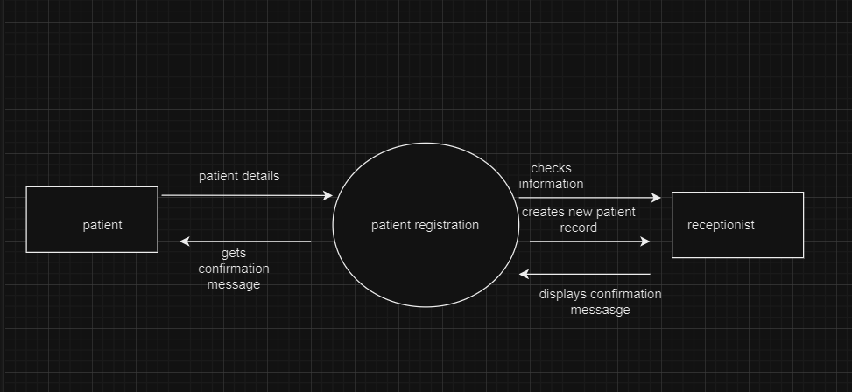

FIG 1.1

LEVEL 1

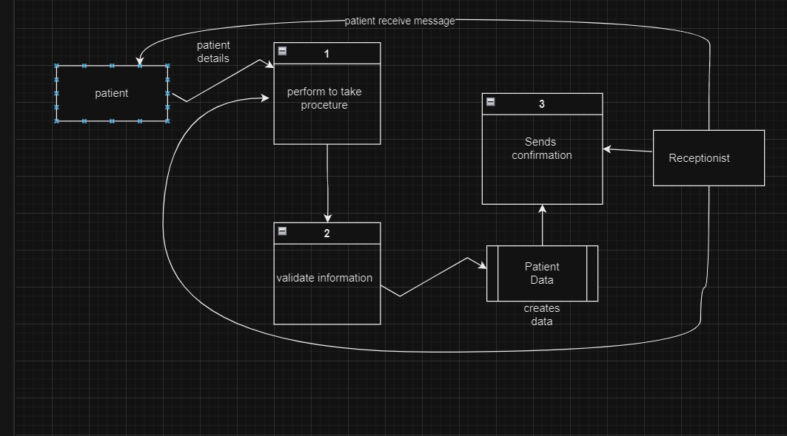

FIG 1.2

LEVEL 2

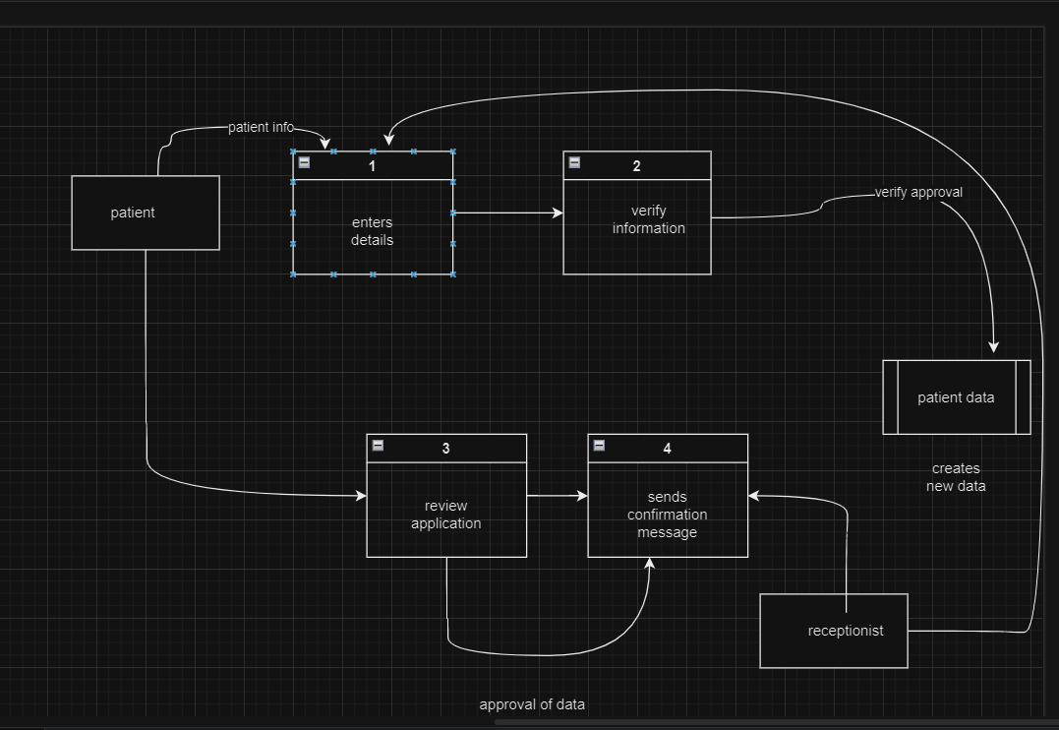

1. Receptionist enters the information about the patient in the system
2. System verifies information
3. System approves and create new data of patient
4. Patient review the data
5. Receptionist send confirmation message

FIG 1.3

1. APPOINTMENT SCHEDULING

When scheduling an appointment, the patient makes an appointment, the receptionist searches the system for open dates, books the appointment, gets the patient's confirmation once more, and then sends the patient a reminder.

LEVEL 0

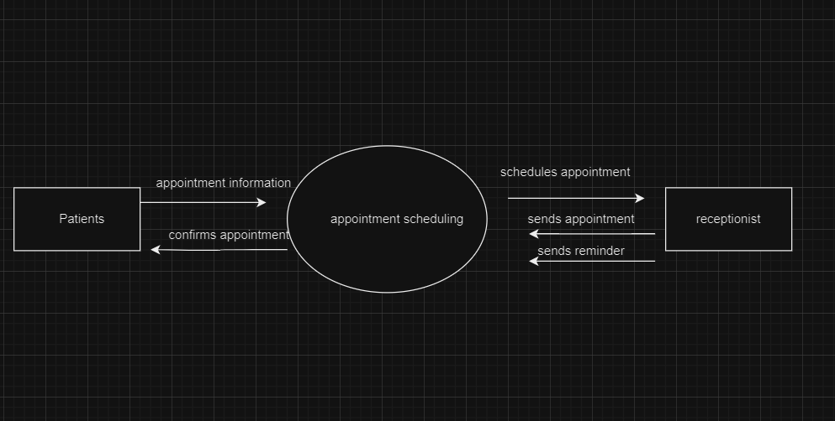

FIG 2.1

LEVEL 1

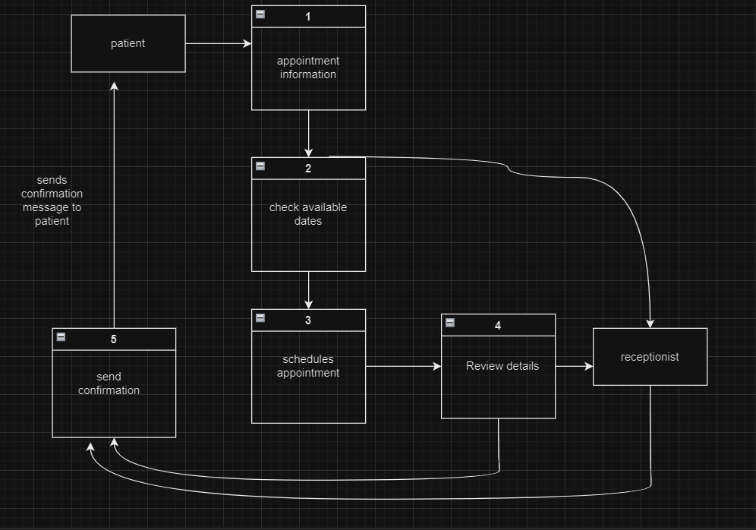

FIG 2.2

LEVEL 2

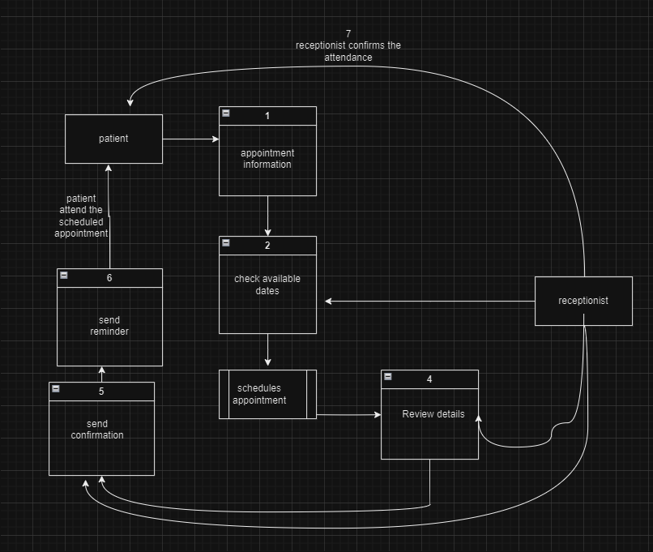

FIG 2.3

1. Patient ask for appointment information
2. System checks available dates
3. Receptionist schedules appointment
4. Receptionist review details
5. System send confirmation to patient
6. Receptionist send reminder and patient attends meeting
7. BILLING AND INVOICING

LEVEL 0

Following the consultation, the billing department creates the bill, which is then sent to the patient. The patient can choose how to pay, and the system then updates the patient's financial position.

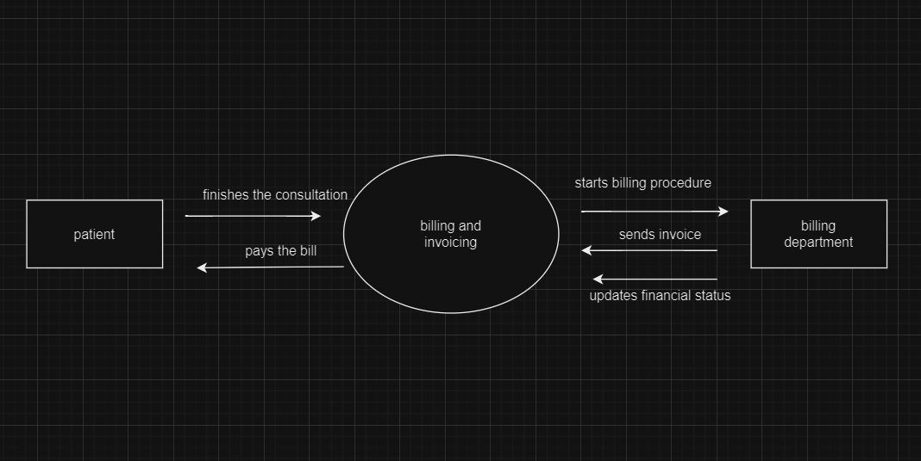

FIG 3.1

LEVEL 1

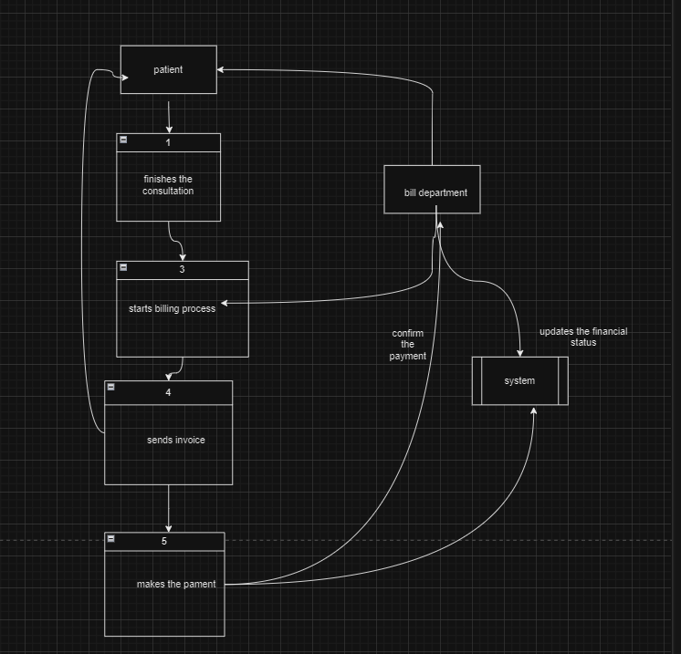

FIG 3.2

LEVEL 2

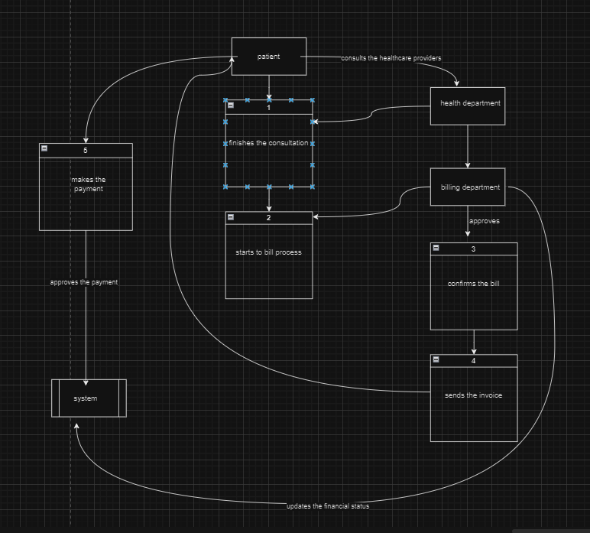

1. Patient finishes the consultation
2. Billing department starts the process
3. Billing department approves and confirms the bill
4. They send the invoice to patient
5. The patient makes the payment
6. System updates the financial status of the patient

FIG 3.3

1. INVENTORY MANAGEMENT

LEVEL 0

The inventory system sends an alarm, the administrator reviews the information, the inventory system sends a recommendation, and the administrator assigns them based on need.

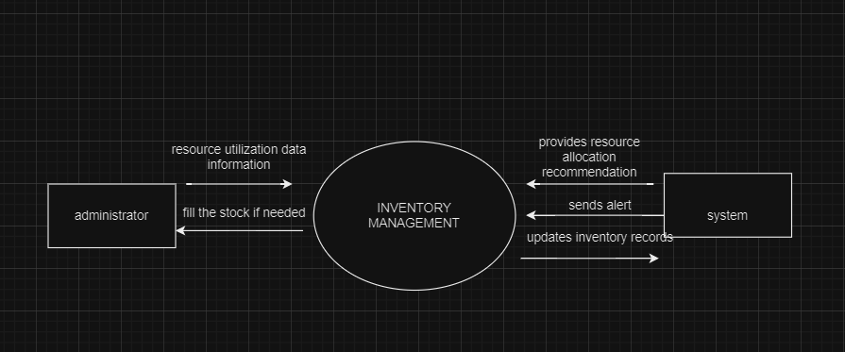

FIG 4.1

LEVEL 1

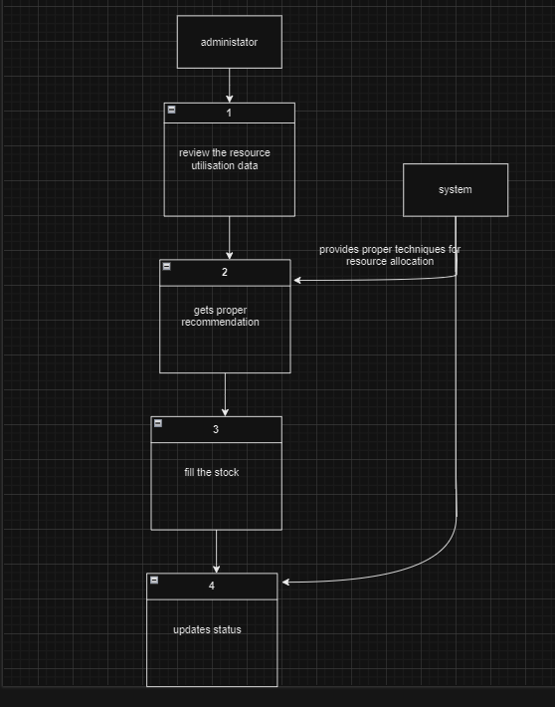

FIG 4.2

LEVEL 2

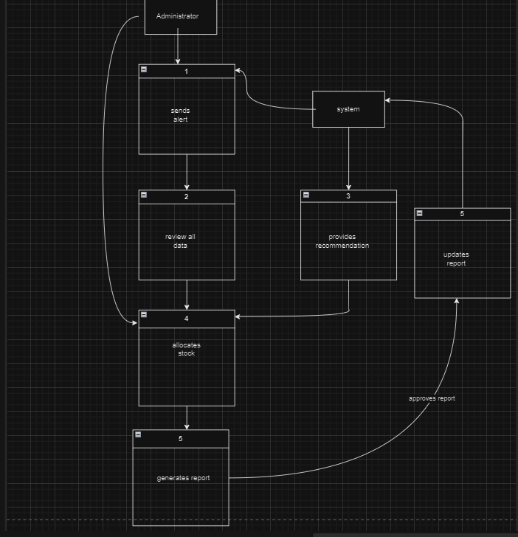

FIG 4.3

1. System sends alarm
2. administrator review all the data
3. system provides recommendation
4. administrator allocates goods
5. they generate report
6. system updates report

# TASK 4

PLANNING

Setting goals is essential to creating a project plan that is both practical and clear. The program ought to streamline procedures, boost output, and automate some jobs. The precise objective must be evident. Consider this while deciding how to measure the project's success.

ITERATIVE DEVELOPMENT

Sprints are brief, time-limited iterations that define agile development. Usually lasting between two and four weeks, each sprint entails the development team focusing on a portion of the product backlog's features. The team calculates the effort required and chooses backlog items to work on based on priority during sprint planning. Every day, stand-up meetings are conducted to coordinate efforts, resolve issues, and schedule the day's tasks. Developers work closely together, continuously merging and testing code changes throughout the sprint.

CONTINUOUS TRANING AND FEEDBACK

A sprint review meeting is held at the conclusion of every sprint to show stakeholders the finished features and get their input. By using stakeholder input to guide the next sprint planning session, the team can adjust and reprioritize backlog items. In order to enable the team to make adjustments for subsequent sprints, a sprint retrospective meeting is also arranged to discuss the sprint's accomplishments and opportunities for development.

For Frontline Staff: The main goal of training modules should be to give staff members practical guidance on how to use the system for routine tasks including billing, appointment scheduling, and patient registration. Practice exercises, interactive simulations, and step-by-step demonstrations to support learning may be included in these modules.

Training modules for managers and decision-makers should give a summary of the features, advantages, and strategic ramifications of the system. The emphasis of these modules can be on analytics and reporting capabilities that support data-driven decision-making.

QUALITY ASSURANCE AND TESTING

Agile development relies heavily on testing and continuous integration procedures. Software quality is ensured by automated testing methods and tools, with developers and specialized quality assurance staff in charge of finding and resolving flaws. Testing happens at every stage of the development process, from acceptance tests conducted during sprint reviews to unit tests conducted during coding.

DEPLOYMENT AND MAINTENANCE

After development is finished, the system is gradually introduced into production, with updates and improvements being made on a regular basis over ensuing sprints. The system is kept stable and functional by post-implementation support and maintenance, which also include continuous monitoring and feedback loops to handle any problems or required changes.

# Reference

<https://bambooagile.eu/insights/software-development-planning>

<https://www.geeksforgeeks.org/levels-in-data-flow-diagrams-dfd/>